**SQL Assignment 2**

1. For an online purchasing database, create entity relationship diagrams. Create a database object from your entity diagr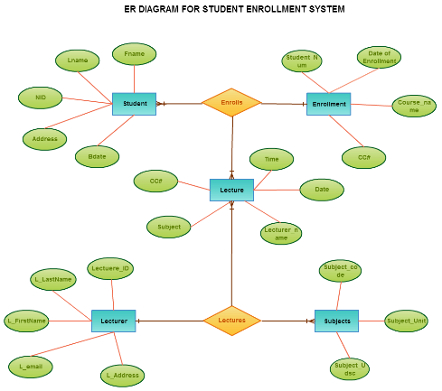am.
2. Create a SQL store process to register the use of the database, complete it with proper validation and transaction rollback and transaction rollback and commit.
3. It provides auto commits functionality, so you do not require to issue a COMMIT TRAN statement. It is a convenient solution, and we can avoid open transaction issues such as session holding resources, but it is not committed.

3. List the SQL aggregate function and demonstrate how to utilize it.

A. column. We often use aggregate functions with the GROUP BY and HAVING CLASSES of the SELECT statement. Various types of SQL aggregate functions are:

1. COUNT()

2. SUM()

3. AVG()

4. MIN()

5. MAX()

4. In SQL, create a pivot query.

A. 1. First, select a base dataset for pivoting.

2. Second, create a temporary result by using a derived table or common table expression (CTE)

3. Third, apply the PIVOT operator.

5. With an example, describe how to join in SQL.

A.  **A JOIN clause is used to combine rows from two or more tables, based on a related column between them.**

**6.** How to locate the 4th highest value in a column in a row. Create your table.

A. **Using this function we can find the nth highest value using the following query.**

1. DECLARE @nthHighest INT = 2.
2. ;WITH CTE(EmpId,Empcode,Name,Salary,EmpRank)
3. SELECT EmpId,Empcode,Name,Salary,
4. DENSE_RANK() OVER(ORDER BY Salary DESC) AS EmpRank.
5. SELECT * FROM CTE WHERE EmpRank = @nthHighest.